No | Pickup Location | Delivery Location | Desk  (plus notes)
1 | PAS 2402 | PAS 1098D | Dean’s  - old desk, and  - side table
2 | PAS 2417 | PAS 2402 | Phoebe’s, move  - Standup desk, and  - Rounded desk/extension  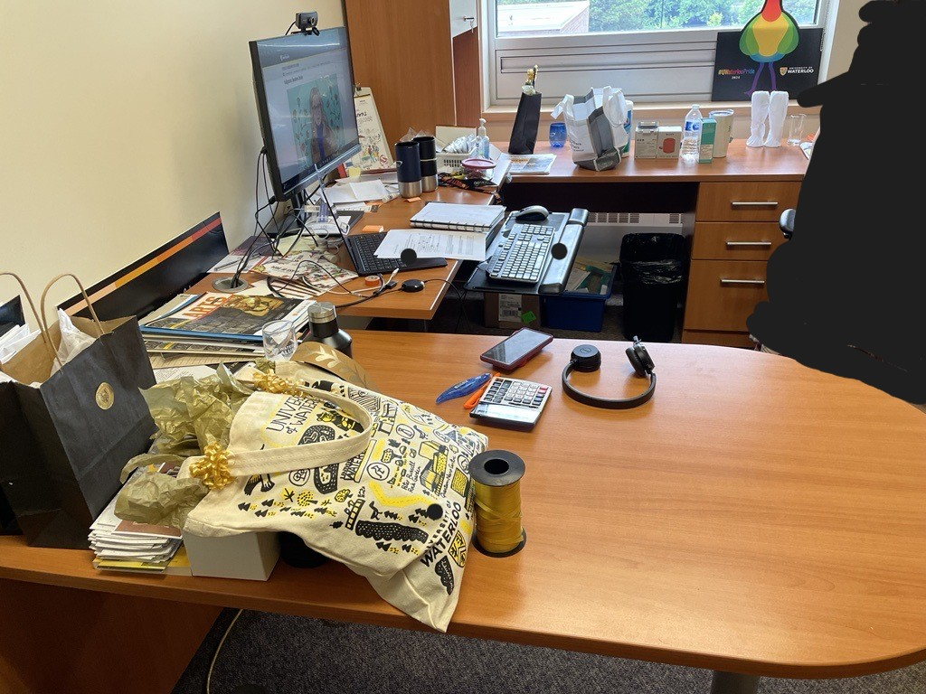  Please note: desk with drawers and overhead cabinet located beside window STAYS.
3 | PAS 2202 | PAS 2417 | Alumni co-op desks x2  - Desk plus overhead cabinets (need lower drawer dismantled)  - Desk (need lower drawer dismantled)  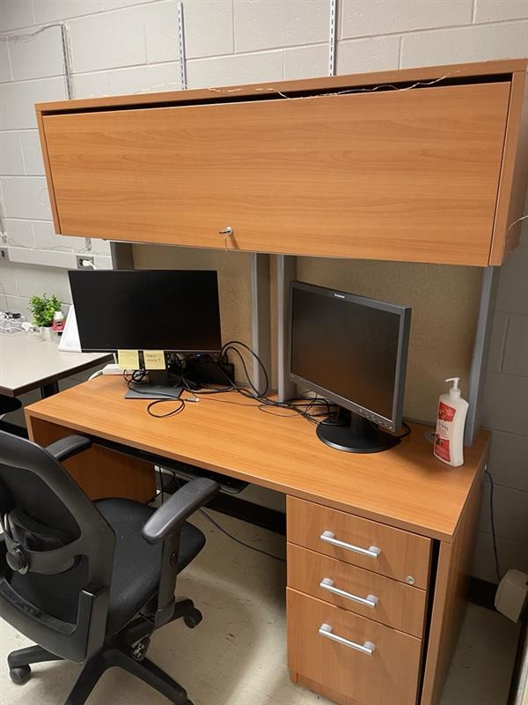  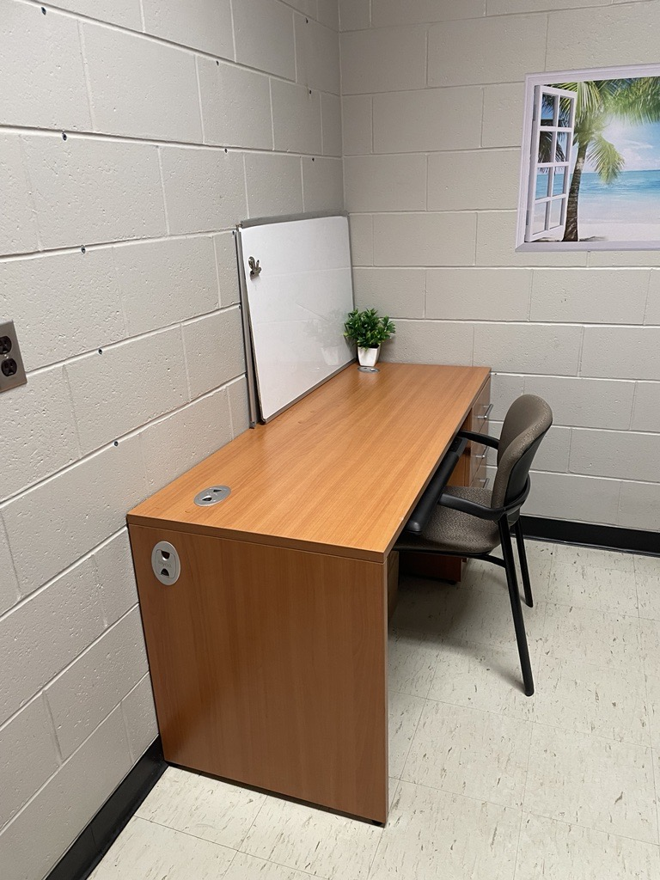
4 | PAS 1098D | PAS 2202 | Storage desk (grey)x1  - Grey desk with overhead cabinet x1  