Add Financial Information
- Scan UWStore special order transaction report
- Save it with naming convention:
  - WStore-Order-######
(e.g. WStore-Order-28184)
- Open CALMS
  - Go to asset
  - Under Files tab:
    - Upload scanned document
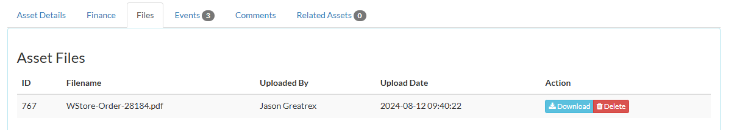
  - Under Finance tab, enter:
    - Purchase type
    - Purchase order no
    - Purchase price
    - Purchased
    - Owner
    - Origin
    - Purchase Comments
(Example below)
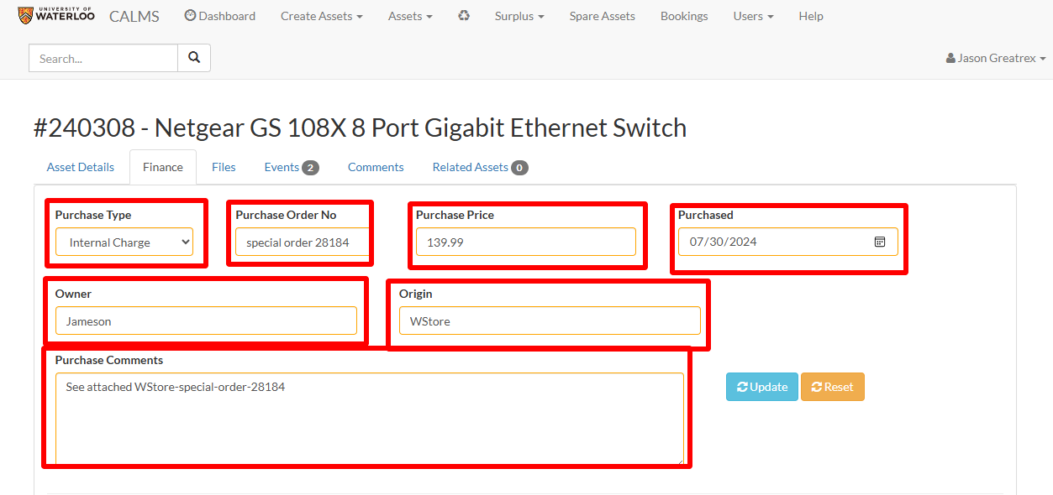
- Under Account Details, enter:
  - Account
  - Amount
  - Comments
  - Save
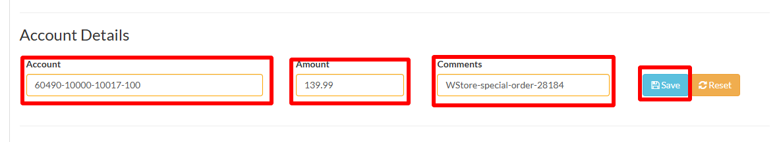
- Under Files tab
- Upload Scanned
Updated Physical Paper Copy
- Add: CALMS Finance data adde
- Date:
- By:

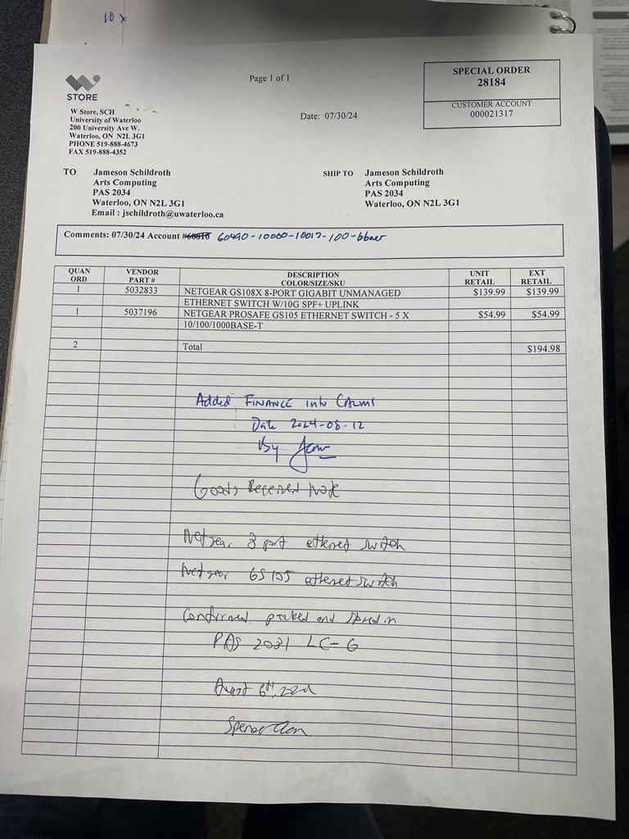
Warranty
- If a warranty is associated with an asset:
  - Under Asset Details tab, update:
    - Warranty field
    - Acquired date
    - Coverage date
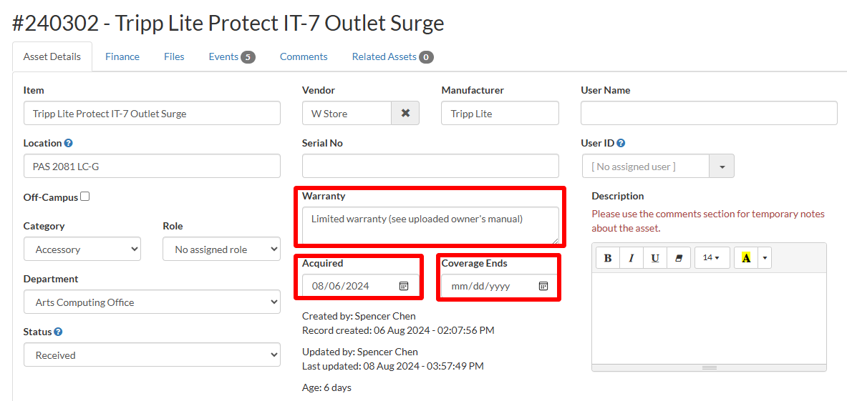
  - Under Files tab,
    - Scan warranty information (OR download from Vendor website)
    - Save it with naming convention:
      - Warranty-product
(e.g. warranty-Tripp Lite Protect IT-7 Outlet Surge)
    - Upload under Asset Files
