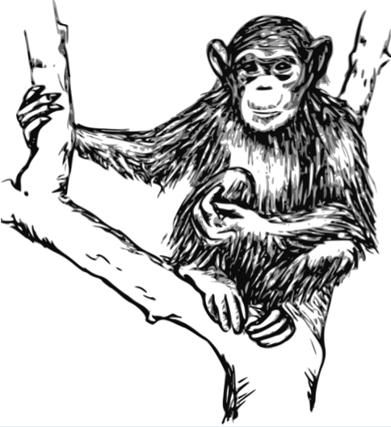
Protect Endangered Chimpanzees
+
Drink FREE Eco-Friendly Coffee

January 22, 10:00-3:00 MultiPurpose Room , SLC

BYOB
[Bring Your Own Bottle]

BYOC
[Bring Your Own Cup]

BYOM
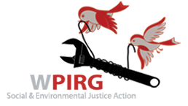
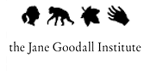

[Bring Your Own Mug]

