UNIVERSITY OF WATERLOO
Department of Anthropology presents
The 2013
Sally Weaver Award Guest Lecture

"The Light of Knowledge: Literacy Activism, Feminism, and the Social in Southern India"

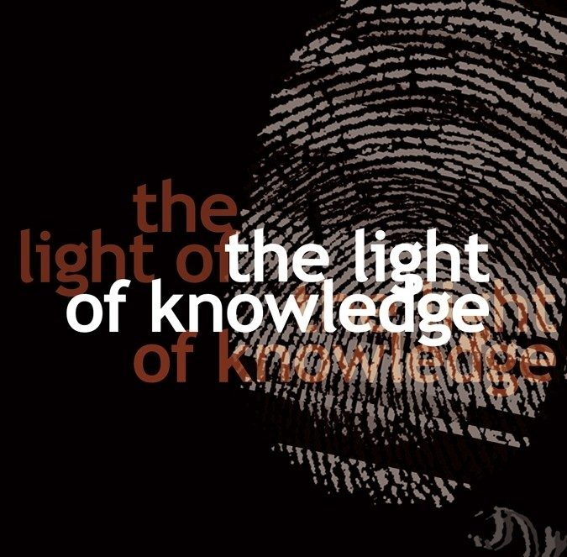

Dr. Francis Cody, Associate Professor
Department of Anthropology and
Asian Institute, Munk School of Global Affairs
University of Toronto

The Arivoli Iyakkam, or "Enlightenment Movement," in rural Tamilnadu is considered to be one of the most successful mass literacy movements in recent times. Activists in this movement taught their fellow villagers written language skills and lessons in grassroots feminism with the aim of producing a modernist orientation to the state and to society. By invoking the ideals of scientific objectivism and stranger sociability, workers in the movement were making claims to forms of affiliation and agency that would transcend what they take to be the restrictive spheres of caste, village, and kin. However, in the process of inculcating what they call a "social perspective," Arivoli activists faced two interrelated problems: there is a duality in their very idea of the social such that it can designate both that which binds in place, slowing the wheels of historical change, and that very collective form of agency that must be made aware of itself for any purposeful large scale change to happen; and secondly, the conceptual vocabulary available for this exercise in abstraction is tied precisely to those regimes of filiation and sociality, frequently rendered as ‘community’, that the broader concept of ‘society’ (as a connection among strangers) was meant to overcome. This presentation accounts for how activists creatively struggled with these problems in the course of a pedagogy that would seek to remake the very people it aims to empower through the written word.

Friday, November 15th
5:00 – 6:30 p.m. in EV3, Room 4412
(the new Environment Building)

ALL WELCOME

