Music and Ritual
MUSIC 390 / 391
Fall 2014

This upper-level course explores aspects of music and ritual from diverse cultures around the world, and provides a forum in which to reflect on our own and other people’s experiences of music and ritual. Regions selected for discussion include Africa, Asia, Europe and the Americas. Topics include the power and intention of music; the role of music in various types of rituals; social functions served by music and ritual; and the adaptation and transformation of music and ritual traditions.

Instructor: Maisie Sum
Time: Mon & Wed, 10:30am-12:00pm
Place: CGUC Rm 1301
Pre-requisite: Mus 100 & Dept consent

For more information contact Maisie Sum at:
msum@uwaterloo.ca

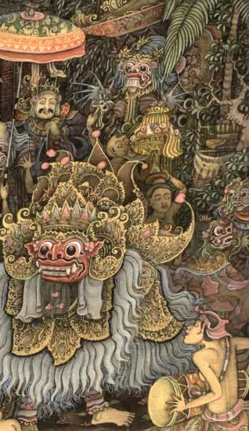
Balinese painting, artist unknown http://charitywebstore0.tripod.com/indexold.htm

