GLOBAL HEALTH
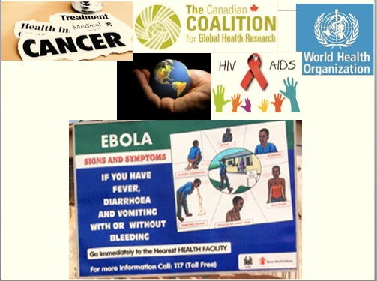

What do we mean by Global Health? What are the goals of Global Health Programs? What kinds of relationships are forged in the name of Global Health? How do Global Health projects play out on the ground?

This course provides an overview of the growing field of Global Health. We will track: the history of Global Health; examine Global Health projects, priorities and ethics; epidemics and biosecurity; emerging technologies including synthetic biology; and Global Health institutions, among other topics.

