History 220: The Vietnam War & American Society
Fall 2014

Professor John Sbardellati
jsbardel@uwaterloo.ca
x32737

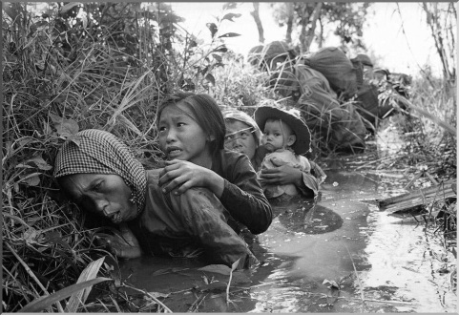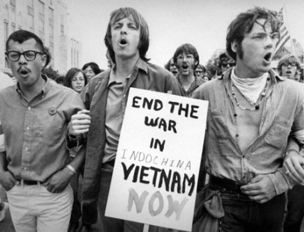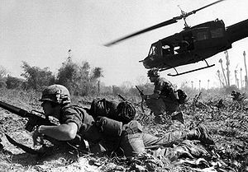

This course examines the history of the Vietnam Wars—the political, diplomatic, ideological, and military struggles waged in and around Vietnam since the 1940s. What began as a French colonial war morphed into an American campaign to prop up an unstable and unpopular anti-Communist regime in the southern part of the country. This American project had a devastating toll, not only in terms of the over 58,000 U.S. lives lost and the subsequent domestic turmoil created by this conflict, but especially in the horrific impact on Indochina, including the millions of casualties suffered by Vietnamese, Laotians, and Cambodians. Our perspective will be international in scope, considering the events in relation to Cold War dynamics, postwar decolonization struggles, Vietnamese history, and, especially, American politics and culture.

Grading:
Midterm 30%
2nd Midterm or Paper 30%
Final exam 40%

uwaterloo.ca/history

