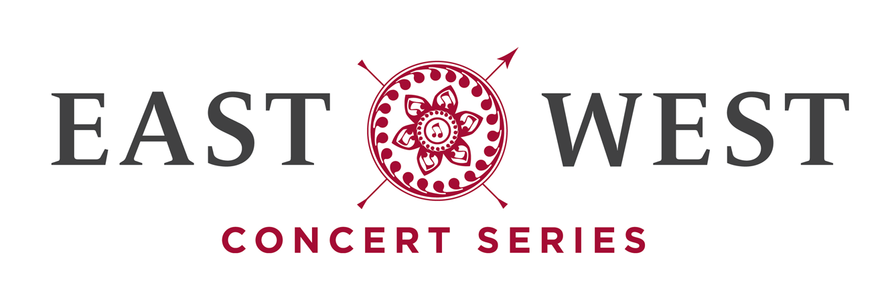

Family:
East-West style
Sponsored by the Confucius Institute, University of Waterloo

Dark Horse Ensemble
Dr. Gerard Yun, director
with Special Guests
Wendy Wen Zhao, international pipa virtuoso
Wendy Lai & Kenny Kwan, Gu-Zheng

Wednesday, March 71, 2013 7:30 p.m.
Luther Village

Programme

Listen with your Heart Traditional Chinese
The Mission of China arr. Wendy Lai and Kenny Kwan
Battling the Typhoon Traditional Chinese
Wendy and Kenny Kwan, Gu-Zheng

Tamuke – Remembering Traditional Honkyoku
Gerard Yun, shakuhachi
My Brother (for Andrew) arr. Gerard Yun and Dark Horse
Dark Horse Ensemble
Wai Zhuang, soprano and composer of “Angel”
INTERMISSION
1. White Snow in Sunny Spring Chinese Ancient
2. Lady Zhao Jun's Lament Chinese Ancient
3. Dance in Yi Village Wang Hui Ran
4. Dragon Boat Chinese Folk
5. Ambush from Ten Sides Chinese Ancient
Wendy Wen Zhao, pipa

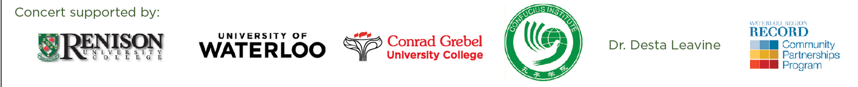

CONCERT NOTES
Canada identifies itself as a land of diversity and multiculturalism. Recently, Kitchener-Waterloo was identified as being one of Canada’s most diverse regions. East-West is not an abstract or novel concept. We are living it here in our local area. Tonight’s East-West Concert focuses on family, particularly the Chinese-Canadian family and their stories. Mother and son Gu-Zheng (Chinese Harp) players Wendy Lai and Kenny Kwan open our concert with traditional and contemporary duets. Composer’s daughter, music producer, composer, and vocalist, Wai Zhuang, joins East-West’s Dark Horse Ensemble in creating a tribute to her family. This new work centres around her younger brother, Andrew, who, despite cerebral palsy, manages to bond and inspire those around him. The second half of our program features international virtuoso, Wendy Wen Zhao in a selection of traditional and contemporary works for pipa (Chinese Lute).
Dr. Gerard Yun, Artistic Director

About the East-West Music Series
The East-West Concert Series was conceived as a joint project between Renison and Conrad Grebel University Colleges at the University of Waterloo. The original intent was to extend community outreach and goodwill through the sharing of cross cultural musics. The East-West Series was founded to build community understanding and interaction through the sharing of arts and music with the stories, impressions, and experiences unique to our community. It features regional and international guest artists as well as the most talented performers from our local community.

Artists
Wendy Wen Zhao is an internationally acclaimed pipa virtuoso, has presented numerous solos and concerto concerts throughout Canada. Born in Beijing, Wen began to study the pipa at the age of seven, eventually winning the first prize at Beijing Youth National Instrument Competition in 1985. After completing her Conservatory study with the renowned pipa master Wang Fan Di in Beijing, she continued her musical career in England, performing and teaching Chinese music throughout the U.K. She lives in Toronto since 1997, and teaches Pipa at both the Royal Conservatory of Music and York University in Toronto.
For the past years, Wen has toured worldwide; including Asia, Europe, Canada and the US, and played solo performance at major ethnic music festivals, at Queen Elizabeth Hall in London, UK, Toronto Roy Thomson hall, Beijing, Shanghai and Hong Kong international festivals. In recent years she has collaborated with some world top Western orchestras include Tafelmusik Baroque Orchestra, the Toronto Symphony and the Toronto Consort. She is especially honored to be one of the featured solo artists for the CBC award-winning documentary film The Four Seasons Mosaic. Her masterful playing deeply impressed the audience and was highly acclaimed by the media: BBC, CBC, OMNI TV all broadcast her in concert. The Toronto Star described her as “Wen Zhao, a virtuoso player who displayed her dexterity and percussive skills on Pipa.”

Wendy Lai was born in Hong Kong where she learned Mandolin and guitar under the guidance of her father at a very young age. She became a Gu-Zheng and Pipa student of Mr. Lam Fung, a famous Pipa soloist. In 1992, Ms. Lai joined the Hong Kong Chuen Yum Gu-Zheng Ensemble and began her own studio.
In 2001, Ms. Lai immigrated to Canada and became a student of the Famous Gu-Zheng Soloist, Ms. Fan Sheung-E. Students of Ms. Lai have earned distinction in Gu-Zheng exams conducted by the Bejing Central Committee and won awards in various open competitions such as the Kiwanis Music Festival of Great Toronto, Markham Fair Festival, and the York Regional Talent Show.

About the Dark Horse Ensemble

Garbrielle Gudidharma, piano and vocals
Kenny kwan, gu-zheng
Kathryn Ladano, bass clarinet
Amanda Lowry, silver flute
Gerard Yun, shakuhaci
Wai Zhuang, vocals

Gabrielle Budidharma emigrated with her family from Jakarta, the capital of Indonesia in 2001. The family settled in the GTA where her parents pursued professional careers while she pursued musical studies. She studies voice and piano at Wilfrid Laurier University.
Kenny Kwan was born in Hong Kong and immigrated to Canada in 2001. His mother, Wendy Lai, insisted on his playing the gu-zheng from the time he was seven years old. Unlike his siblings Kenny continued his studies throughout his teenage years. He is currently majoring in piano performance at Wilfrid Laurier University.
Kathyrn Ladano is one of Canada’s premiere bass clarinetists and a founding member of Dark Horse. . She is a specialist of contemporary music and free improvisation and has performed as a soloist and chamber musician across Canada and abroad. She currently directs the Improvisation Chamber Ensemble (ICE) at Wilfrid Laurier University and regularly appears with Dark Horse co-founder, Richard Burrows in the musical duo, “Stealth”. Kathryn holds a Master’s degree in bass clarinet performance from the University of Calgary and an Honours Bachelor of Arts degree in music from the University of Waterloo. She is the recipient of several grants and is currently pursuing the Ph.D in improvisation studies at York University.

Amanda Lowry started on the silver flute at age 10 in a highly supportive, musical atmosphere. She majored in flute performance, composition, and improvisation at Wilfrid Laurier University where she also fostered an interest in cross-cultural .musics. While enamored of Western classical music, she eventually found the approach too narrow, especially for a contemporary composer. Amanda is currently pursuing graduate studies in composition at the University of Toronto. A gifted improviser, Amanda was recently featured as a member of The Hour Glass Ensemble, under the direction of international improvisation specialist, Dr. Peter Wiegold.
Wai Zhuang was born in Bejing, China. Her father is composer, Jianhua Zhuang, an associate composer with the Canadian Music Centre. After attending high school in the Toronto region, Wai relocated to Bejing to pursue studies in Chinese popular music. She appeared in The X Factor: Ji Qing Chang Xiang (the Chinese version of X Factor) and “Super Girl” (the most popular entertainment show in China) before returning to Canada to pursue classical music studies at Wilfrid Laurier University.
Dr. Gerard Yun is artistic director of the East-West Concert Series and music director of Dark Horse, East-West’s resident performance ensemble. Dr. Yun seeks out local and international guest artists in traditional and contemporary musics while creating new works through narratives and collaborations with artists across cultures. East-West presents cross-cultural musics united by universal themes that directly affect our local, multicultural community.
Dr. Yun teaches music courses and directs ensembles at Wilfrid Laurier University, Conrad Grebel University College at the University of Waterloo, and York University where he is instructor of Japanese Zen Buddhist Shakuhachi (vertical bamboo flute).

Acknowledgements
On behalf of the East-West Ensemble, I would like to thank the following individuals
and groups for their invaluable contributions towards this evening’s concert.
Luther Village Staff & Residents
Caroline Woerns
Betty Leventhal and Barry Kay
Dr. Lee Willingham
Prof. Yan Li
Dr. Gary Okahiro
Steven Kikugawa
Conrad Grebel University College
Special thanks go to the Confucius Institute, University of Waterloo which is housed at Renison University College. The Confucius Institute is a non-profit organization dedicated to the promotion and development of the Chinese language, culture, studies and business.
The Confucius Institute is a joint-venture between the Office of Chinese Language Council International, the University of Waterloo, Renison University College and Nanjing University, one of China's top universities.
Our venue was made possible by the generous support of Luther Village, and in particular Gwynne Redford and staff who worked tirelessly to make this event possible.
.

Upcoming East-West Concert
East-West: Time to Dance
Wednesday, Jun 12, 2013 at 7:30 pm
Renison University College
“East West Friendship Garden”

