UNIVERSITY OF WATERLOO
Department of Anthropology presents
the 2014
Sally Weaver Award Guest Lecture

The Challenges of Doing Indigenous Archaeology
in Canada

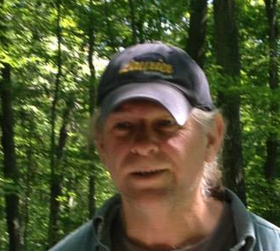

Dr. Gary Warrick, Associate Professor,
Society, Culture, and Environment and Indigenous Studies,
Wilfrid Laurier University (Brantford)

Indigenous archaeology advocates a decolonizing approach to doing community-based archaeology with, by, and for Indigenous peoples on their ancestral sites. Decolonization of archaeology is a laudable goal, but there are a number of serious challenges to its actual achievement. This presentation will examine the political and ethical problems faced by an archaeologist intent on doing research archaeology in collaboration with Indigenous communities in Canada.

Wednesday, November 19th
5:30 – 7:00 p.m. in EV3, Room 4408

ALL WELCOME

