Can We Accommodate Religious Objections to Same Sex Marriage?
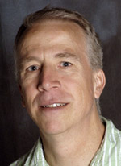
Richard Moon, Professor of Law, University of Windsor

An internationally recognized expert on freedom of expression and religion, Dr. Moon is author of The Constitutional Protection of Freedom of Expression (U of T Press, 2000) and Freedom of Conscience and Religion (Irwin Law, 2014). He has received both the law school and university-wide teaching awards as well as the Mary Lou Dietz Award for contributions to the advancement of equity.

Date: Monday, March 9, 2015, 2:30 p.m. – 4:00 p.m.
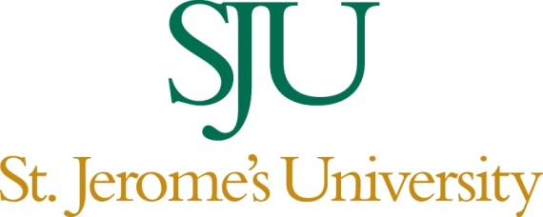
Place: Arts Lecture Hall, Room 211
All are welcome. Wheelchair accessible.
For information contact Dr. Nick Shrubsole, Department of Religious Studies,
St. Jerome’s University: nshrubso@uwaterloo.ca

Sponsored by the Department of Religious Studies at St. Jerome’s University.

