Join the Dean’s panel discussion at Reunion 2015:
“The Sandwich Generation – Impacts and Influences”
Saturday, October 3 from 10:45 am - 11:30 am in AL 105

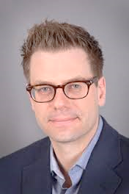
Professor Martin Cooke, Sociology & Legal Studies
TITLE: What the sandwich generation needs
Canada has been transformed by demographic change. We are living longer than ever before, and population aging has taken place along with other dramatic changes to marriage, family, work, and education. Many Canadians in their 40s, 50s, and 60s find themselves under new pressures, including being caregivers for multiple generations. Martin Cooke says these changes have important implications for public policy, which needs to adapt to support the “sandwich generation.”

Professor Kate Rybczynski, Department of Economics
TITLE: Women in the sandwich generation
Professor Kate Rybczynski says the sandwich generation represents new challenges for both individuals and policy makers, and greater attention is now focused on the importance of equity and women in the economy. Women frequently take on a disproportionate share of home production. Many women seek out flexible work arrangements, including self-employment, in order to better balance their family and career commitments. Networks of mompreneurs are becoming prevalent.
Professor Igor Grossmann, Department of Psychology, and Principal investigator, Wisdom and Culture Lab
TITLE: Culture, change, and interpersonal conflict
How do changes in society impact relationships between the generations? How can we boost wisdom in the face of possible interpersonal conflicts? Social psychologist, Professor Igor Grossmann, will explore these challenges, drawing on research from his "Culture & Wisdom" laboratory.

