Confessions

**of a**

**Feminist Killjoy**

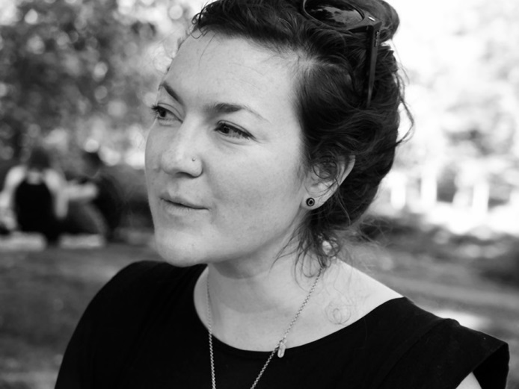**Erin Wunker** (Acadia University) is a feminist killjoy, and she thinks you should be one, too! She brings memoir, literary criticism, pop culture, theory, and feminist thinking *together to introduce Sara Ahmed’s* figure of the feminist killjoy as a lens through which to read the world.

**Erin Wunker’s** brand new book ***Notes from a Feminist Killjoy* (2016)** has been named **Quill and Quire Fall 2016 Non-Fiction Preview Selection** and **49th Shelf Most Anticipated Fall 2016 Non-Fiction Preview Selection.** She is Chair of Canadian Women in the Literary Arts (www.cwila.com) and co-founder of Hook & Eye: Fast Feminism, Slow Academe (www.hookandeye.ca).

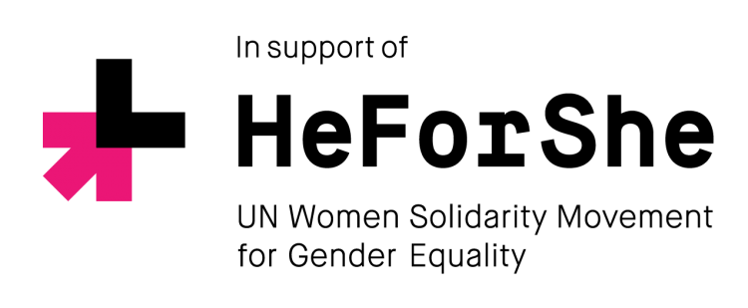

**Thursday, November 3, 2:30 p.m. Room SJ1-3014**

**St. Jerome’s University.** Free. Open to all.