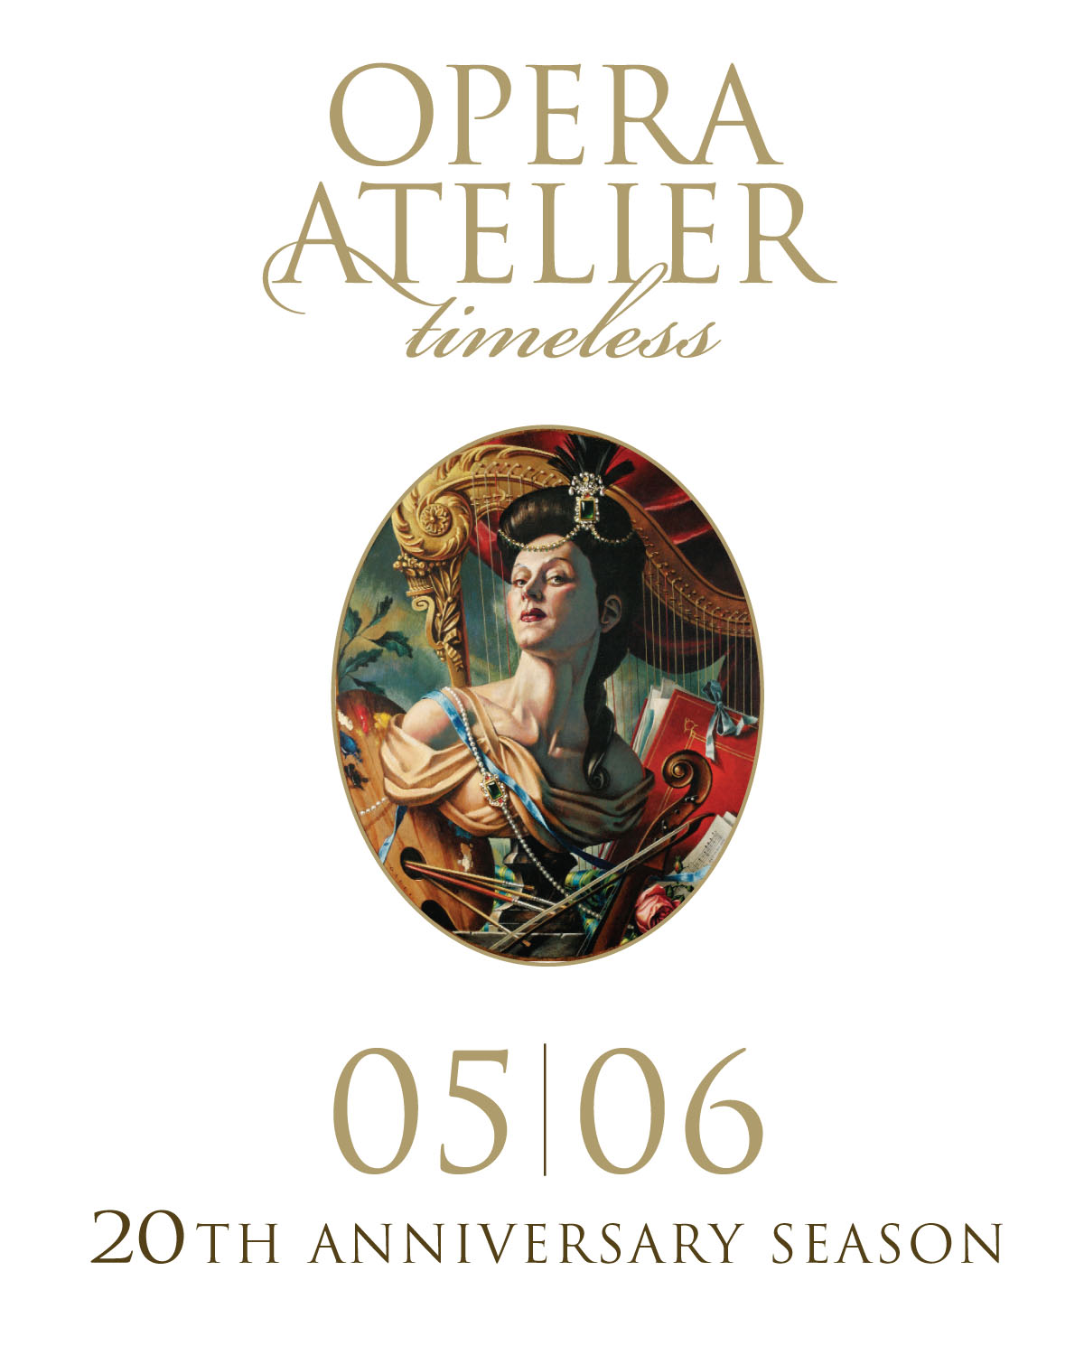

Setting the Stage: 20 years of Design for Opera Atelier

Opera Atelier and the Toronto Public Library present Setting the Stage: 20 years of Design for Opera Atelier, from February 9 to April 30, 2006 at the Toronto Reference Library TD Gallery (789 Yonge Street). Part of Opera Atelier’s 20th Anniversary celebrations, this extensive exhibit traces the company’s design process and showcases its spectacular and distinct house style.

Setting the Stage features set designs by renowned Canadian artist Gerard Gauci from the collections of both Opera Atelier and the Toronto Reference Library, a photographic history of the company’s productions by Bruce Zinger, specialty props by Toronto mask-maker Karen Rodd and exquisite costumes by Dora Rust-D’Eye.
In addition, a virtual exhibit will be available to view online at: http://ve.torontopubliclibrary.ca/operaatelier/index.htm
Designer Gerard Gauci will be present on Thursday, March 16 at 5:30 pm and Saturday, April 8 at 2:00 pm to give an artist talk and guided tour of the exhibition.

In conjunction with the exhibit, Opera Atelier artists will perform at the launch of the Toronto Reference Library’s new On Stage Program on Friday, April 21st at 7:30 p.m. in the Atrium (located on the main floor).

Admission to the exhibit and all the programs is free. The Setting the Stage exhibit is open to the public during regular TRL hours: Monday – Thursday 10 am – 8 pm; Friday & Saturday 10 am – 5 pm; Sunday 1:30 pm – 5 pm. For more information call 416-703-3767 ext. 29 or 416-393-7131, or visit www.operaatelier.com .

-30-
Media Contacts:
Karen Lorenowicz or Tania Ensor
Opera Atelier Toronto Public Library
416-243-0168 416-393-7193
karen.l@sympatico.ca

