SECOND CALL FOR PAPERS

International Conference in conjunction with the International Steelpan Association

“CARNIVAL, ‘PEOPLE’S ART’ AND ‘TAKING BACK THE STREETS’ ”
July 30-August 3, 2008, Toronto, Canada
Accolade Centre at York University and Koffler Student Centre at the University of Toronto
www.yorku.ca/CarnivalConference

Spreading from Trinidad through the Caribbean, to Canada and England as well as Germany, and with analogues in Brazil, the United States and elsewhere, Carnival has developed into one of the most important global expressions of popular identity. Both as celebration, and as resistance art, it builds on the collision of cultures of Christian European colonizers and enslaved West Africans. The claiming of public space in the use of the street is a statement of presence that is as much political as artistic. Organized to coincide with the Caribana Festival on the streets of Toronto, this conference addresses such important issues as Globalization and Commercialization, the formation of Diasporas, Pan-Cultural Hybridity, the origins and development of Carnival, Gender and Racism, the nature of Postcolonialism today.

Held as part of the Caribana Festival and Parade, and with the International Steelpan Association, the conference is designed to merge theory and practice.
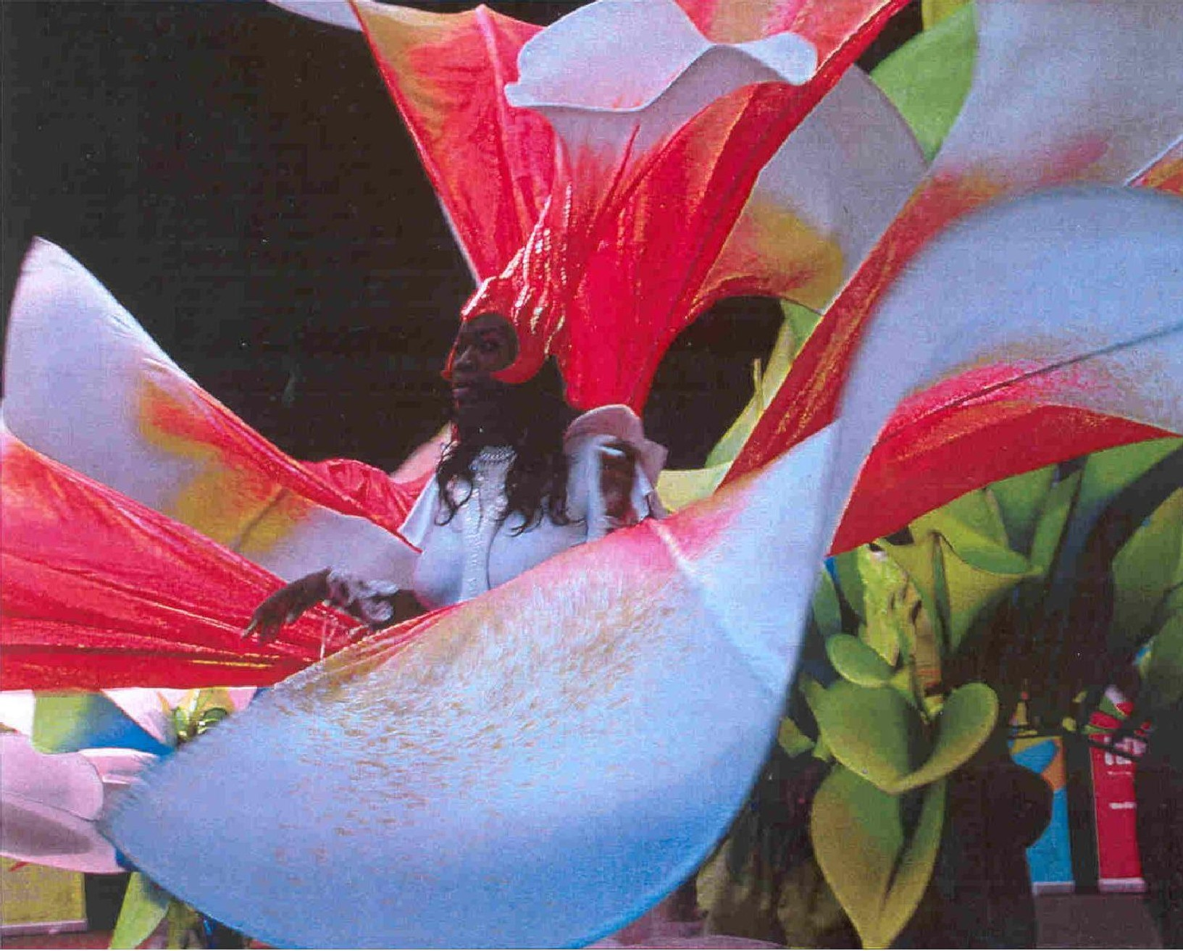

The conference will explore the social, political and cultural aspects of Carnival and street theatre, as well as themes of exclusion/otherness, exoticism and cross-cultural acceptance, connections across the Diaspora, and comparisons between Carnival in Africa, the Caribbean, South and North America, Europe and the UK. Papers that address any aspect of these areas are welcome; and there will be two New Scholars Panels, for which students are particularly invited to submit papers. While taking African Carnival and its spread across the Caribbean to other continents as its base, this conference is also intended to focus on the widest socio-cultural aspects of this performative street art: the negotiation of hybrid identity in the post-colonial context; anthropological views of historical developments, the politics of carnival and street theatre, the economics and commercial pressures. Suggested topics for papers include, but are not limited to:
* Carnival and theatricality * Images of Africa / Carnival in Africa
* The Trinidad Carnival Tradition * Myth, Magic and Ritual
* Economics and Carnival * Social Activism & Street Theatre
* Popular Art, Globalization & Copyright * Gender, Sexuality, Satire
* Caribana: history, performance * New Orleans Mardi Gras
* Cross-Cultural Influence: Brazil, Bolivia, Berlin * Notting Hill Carnival
Proposals for seminar topics also are welcome; and submissions are invited for seminars on:
* Theorizing Carnival * Cultural Rights in a Transnational Festival
* Carnival as a Vehicle for Protest * Carnival in Literature
* Politics of Carnivals and Festivals * Documenting/ preserving Carnival materials
There will also be Workshops on * Producing Carnival – and on – * Carnival Artists and Design

Submissions: Prospective participants should submit abstracts of between 100 and 300 words, for individual papers, seminars or workshops, by the FINAL deadline of MARCH 15th 2008. Abstracts should be sent by email to carnival@yorku.ca. Abstracts must include the title of the paper or presentation, the name(s) of presenter(s); institutional affiliation; email address, phone & Fax numbers. Students should identify themselves as New Scholars.

Special Features: * Staging of a new calypso musical by Tony Hall * Presentation of a performance piece by Eintou Springer * Major Exhibition of Carnival Art * Viewing Kings and Queens Competition and Caribana Parade * Steelpan Music and Panels * Presentation of Carnival Videos * Special Victoria&Albert Museum seminar
CONTACT: Prof. Christopher Innes, Canada Research Chair, 303H Goldfarb Centre, York University - cdinnes@hotmail.com

