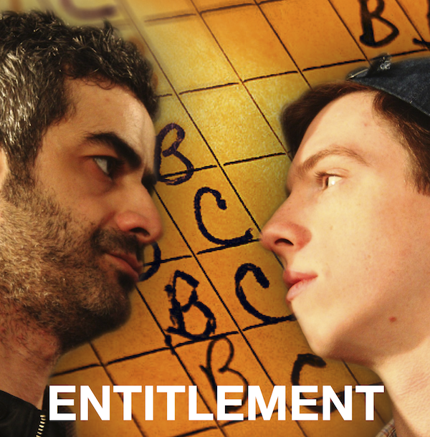

Educators:

ENTITLEMENT, a new play by award-winning screenwriter and actor Sugith Varughese premieres at the Summerworks Theatre Festival in Toronto, August 8-18. Directed by acclaimed director and actor, David Ferry, the play explores the current state of education as it has become transformed to “edutainment” by a system dependent more on maintaining tuition income than maintaining standards.

A biting satire, the play is set in a modern day college, run a dynamic young female Dean, played by Dora-award winning actress KAREN ROBINSON. She hires an out of work screenwriter, Anish, played by SAM KHALILIEH, to teach an introductory scriptwriting course in her new filmmaking program. But Anish’s methods to bring industry-level standards to the millenials in the program are challenged by an entitled young student, Dylan, played by newcomer CHRISTO GRAHAM. As the three poles of education – instructor, student and administrator -- battle for control, the play brings all to a confrontation and ultimately a new understanding of what is at stake for each of them going forward.

Timely, funny and painfully honest, the play is partly based on the playwright’s experiences teaching scriptwriting at the college level. The issues raised by the play will be recognized by educators of all levels and will provoke some lively debate afterwards! Educators will find this play provocative and engaging.

ENTITLEMENT plays at Theatre Passe Muraille’s mainspace, 16 Ryerson Avenue, Toronto ON (one block Northeast of Bathurst and Queen):

August 8, 9PM
August 11, 1:30
August 12, 4PM
August 13, 6:30
August 14, 9PM
August 15, 1:30
August 18, 4PM

Tickets $15 at door
Advance tickets:
Online at ticketwise.ca
In Person at Lower Ossington Box Office, 100A Ossington Ave from August 6-18 10AM-7PM
By Phone at 416-915-6747 10AM-5PM

