Call for Presentation Proposals!!

Puppeteers of America National Festival
August 10-16, 2015
University of Connecticut

The Professional Day for
Teaching Artists and Therapists

August 10, 2015
8:00 a.m. – 3:30 p.m.

Curated by Judith O’Hare

“Teaching artists are professional artists who have also developed the ability as educators to effectively draw people into the arts and artistic engagement. Teaching artists are relied on in organizations including schools, arts institutions, senior centers, juvenile justice and corporate programs, to engage audiences and incite active arts participation. The teaching artist field has rapidly grown in the last two decades as their skills become progressively more important in a world where creativity is increasingly associated with productivity.”
- David Marshall, Massachusetts Cultural Council.

The Professional Day for Teaching Artists and Therapists is Professional Development for puppeteers, educators and therapists who would like to be more effective while working in educational and therapeutic settings.

Presentation Proposals can include:
• projects that have been effective and how they have met the Common Core and state standards
• information for evaluating process and results
• training needed to be an effective Teaching Artist
• research and advanced graduate study
• use of technology
• the role of Puppetry and the Arts in education and therapy today
• how puppets relate to current educational philosophies in multiple intelligence, learning styles, literacy, and other curricular topics
• guidelines and practices in using Puppetry in therapy
• current philosophy on the use and effectiveness of Puppetry in therapy
• other relevant topics

Each Presenter will be allotted 30 minutes - 20 minutes for the presentation and 10 minutes for discussion. Presentations should be focused on one topic and timed to allow for lively discussion.

Digital Projection will be available. Presenters should bring the appropriate dongle to connect their device to a VGA cord.

A certificate of completion will be given to Presenters and Participants to use for professional development points.

Graduate Credit will be available through the University of Connecticut School of Education.

All Presenters will receive FREE REGISTRATION for the Professional Day for Teaching Artists and Therapists.

Proposals:

- Should be sent to PuppetFest@uconn.edu, with the subject heading “PDTAT Proposal”
- Should include:
  - Name, affiliation and contact information (Address, Phone, email, Web Site)
  - The title of the presentation that you would like to offer.
  - Do you work with children and/or teachers?
  - In an attachment
    - a one-paragraph description of your presentation.
    - a brief, specific overview of the presentation, including: target population; duration of the project; type of assessment; how it relates to goals, standards, educational styles, buzz words of the day, etc. Be Specific!
    - the experience that leads to your making this presentation.
    - A short bio.

Deadline for proposals: November 1, 2014

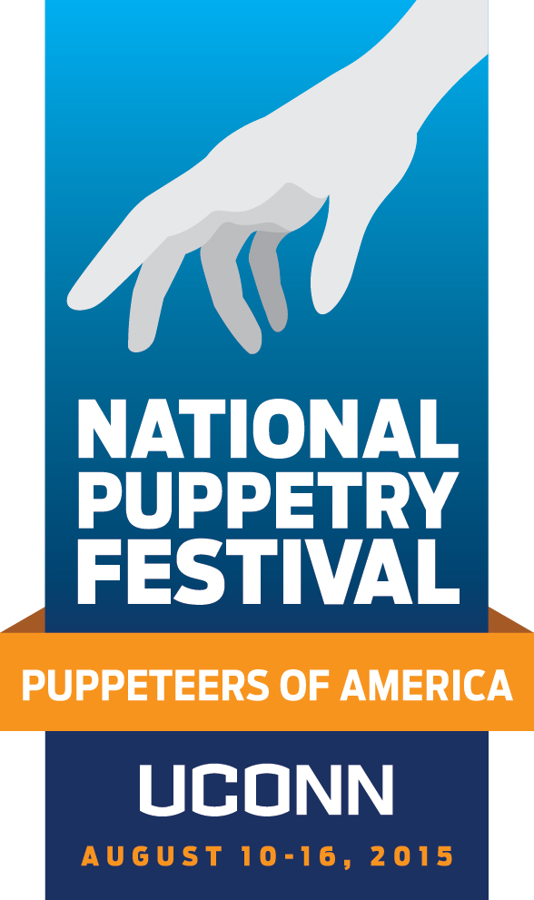

Participant Registration begins January 2015

register online at nationalpuppetryfestival2015.com

Visit our facebook page—Puppeteers of America 2015 National Festival at UConn—for updates, volunteer opportunities and more

