Call for Participants and Presentations!!

Puppeteers of America National Festival
August 10-16, 2015
University of Connecticut

The Critical Exchange

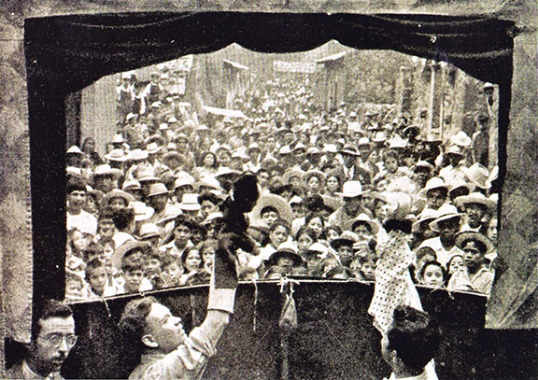
Mexican teatro guiñol in 1940, from the collection of Roberto Lago.

Curated by Claudia Orenstein

The Critical Exchange is a series of discussions among practitioners, critics, and scholars, on selected topics, taking place during the 2015 Puppeteers of America National Festival, and co-sponsored by UNIMA-USA (the American Center of the Union Internationale de la Marionnette), which seeks to foster and enhance critical engagement within the puppet arts.

We are looking for participants from the fields of puppetry, theater, dance, visual art, film, animation and other related areas who would like to bring their thoughtful views about puppetry to address the topics listed below.

Participants may propose to address a topic by offering any of the following:
- a scholarly presentation
- a position paper
- a performance, film, or other artistic work
- to serve as a discussant or respondent
- something else you would like to offer that we hadn’t thought of but is completely relevant

Topics:

1. Necessary Bedfellows: Scholarship and Practice
Tensions often exist between those involved in practicing an art and those engaged in critical discussion of it. How and why do scholars, critics and practitioners need each other? How does critical discussion enhance the world of the arts, both its appreciation and its practice? What can scholars and practitioners learn from each other? How can individuals move back and forth between these worlds of engagement, or combine them? How can theory inform practice, and practice inform theory?

2. Crossing Boundaries
This session deals with the increasing expansion and mixing of materials and forms that fall under the rubric of puppetry. How has the idea of “puppetry” expanded in the last twenty years? What has been lost and what has been gained in this new model? What role does/can the human body play within this enlarging realm of materiality on stage? How do directors, choreographers, puppeteers, actors, and dancers make choices about what goes on stage and why? In what ways does the idea of “puppet” or other models serve as a guide to the puppet director-performer?

3. Marginalized Players
How have women, minorities, gay and queer individuals and other marginalized groups been a part of the art of puppetry and contributed to the art form? Does a marginalized art form, as puppetry has often been, attract and make a place for marginalized individuals or not? Have the issues of these communities expressed themselves through puppetry? When and how? Or has puppetry played another role? Does puppetry provide a place to hide or a place from which to come out? How does sociology interface with aesthetics and dramatic content? How might the history of puppetry be written to reflect its inclusion or exclusion of marginalized groups?

4. Child’s Play
In the United States and many other countries around the world puppetry has primarily been seen as an art form addressing children. But how does it address them? What possibilities exist for children’s puppetry that have yet to be mined? Does the identification as “children’s fare” necessarily limit or direct the types of shows that can be produced? What kinds of exchanges might exist or be created between children’s shows and those for more mature audiences, and how might cross-fertilizations between them work to enrich the art at both ends or bring them together?

5. Predictability and Surprise
Puppetry seems to have blossomed in recent years, expanding in a multitude of new directions that engage older puppetry traditions and invent new ones. But experimentation inevitably hardens into convention. How do the tensions between convention, technique, tradition, and predictability on the one hand, operate in relation to experimentation, innovation, aliveness, and surprise on the other? When and how does convention inform the artist? When does it cease to serve? How can practitioners balance between these poles?

Proposals:

- Should be sent to PuppetFest@uconn.edu, with the subject heading “Critical Exchange Proposal”
- Should include:
  - Name, affiliation, and contact information
  - The name of the topic above that you would like to address.
  - In an attachment
    - a one-paragraph paper abstract or description of your presentation or artwork, including the topic you would address, or
    - for those proposing to be discussants, a brief outline of your relationship to the topic, why you are well placed to discuss the issue, and the types of views you hope to explore during the session.

Deadline for proposals: November 1, 2014

Other Paper Topics:
We also welcome for consideration proposals from scholars and critical thinkers working in the field of puppetry who may wish to give a short paper or presentation on other topics:

- As above, please send your proposal to PuppetFest@uconn.edu, with the subject heading “Critical Exchange Proposal”
- Include
  - Name, affiliation, and contact information
  - Title of your paper or presentation
  - In an attachment, include the title and a one-paragraph abstract of your paper or topic
Deadline for proposals: November 1, 2014

Co-sponsored by UNIMA-USA

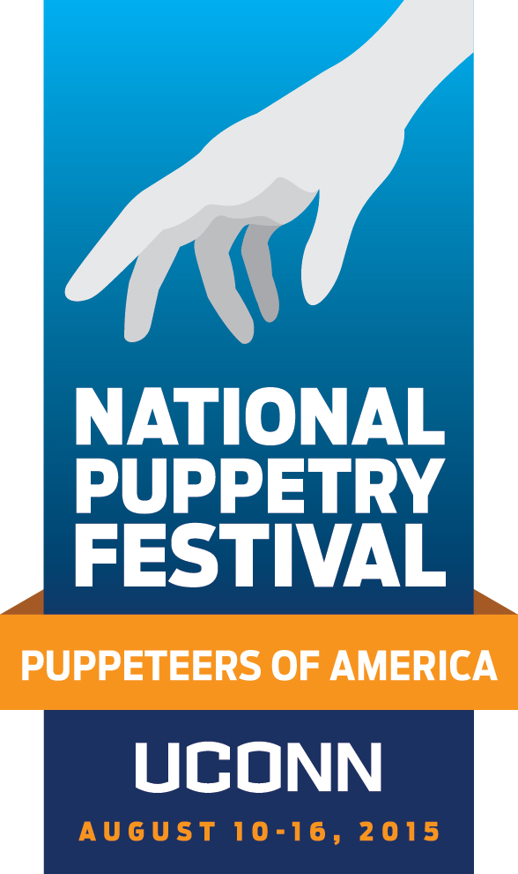

Participant Registration begins January 2015

register online at nationalpuppetryfestival2015.com

Visit our facebook page—Puppeteers of America 2015 National Festival at UConn—for updates, volunteer opportunities and more.

