PROSTATE CANCER: HOW MANY DIFFERENT TYPES ARE THERE?

The Wall Street Journal - HEALTH JOURNAL
JUNE 29, 2010
The Prostate Cancer Quandary
By MELINDA BECK

Scientists may soon be able to answer the agonizing question facing men with prostate cancer: Does their cancer need immediate treatment or can it be left alone?
Some 218,000 American men will be diagnosed with prostate cancer this year. An estimated 85% of those tumors will grow so slowly that they will never cause problems. But the rest are aggressive and lethal. As of now, there's no way to tell early on which cancers are which, so tens of thousands of men undergo surgery or radiation each year for cancers that never needed treatment, risking impotence or incontinence in the process.
Several recent genetic discoveries could help doctors evaluate how aggressive a man's prostate cancer is much earlier. Scientists at the University of Michigan have identified at least 24 different kinds of prostate cancer of varying virulence whose DNA signatures can be read like a bar code. Memorial Sloan-Kettering Cancer Center researchers have identified other genetic subtypes of prostate cancer that seem to predict whether the tumor will be low or high risk. And Harvard Medical School scientists have found a specific gene that causes prostate cancers to spread. Some of the discoveries also could lead to new treatments, tailored specifically for the kind of prostate tumor a man has.
Such genetic tests for prostate cancers would go well beyond the current PSA test (for prostate-specific

antigen) used for screening men in general. PSA tests have helped find prostate cancers at much earlier stages, saving thousands of lives in recent years. But PSA levels also rise for reasons that have nothing to do with cancer, prompting many men to have prostate biopsies each year that don't find cancer or that find tumors of the slow-growing variety.
Scientists say new prostate-cancer tests could be available in the not-too-distant future. "It won't be tomorrow, but if you go by the pace at which such technology entered the field of breast cancer, it will be several years [for new prostate tests], not a decade," says Charles Sawyers, chairman of human oncology and pathogenesis at Memorial Sloan-Kettering.
At the University of Michigan, researchers have focused mainly on what are known as gene fusions, in which DNA from some genes gets stuck to other genes, altering what they do. Two of the 24 types they have identified involve the same gene, known as RAF, that drives malignant melanoma, according to a report in the journal Nature Medicine this month. Although those two types make up only about 2% of the tumors studied so far, they are highly aggressive, killing an estimated 3,600 men each year.
Treatment for those prostate cancers is on the horizon. Several anti-RAF drugs to treat melanoma have regulatory approval or are in late-stage clinical trials. Early lab tests show that some of those drugs are effective against RAF prostate-cancer cells.
What the Genes Tell
Researchers are closing in on ways to determine whether a prostate tumor is likely to metastasize, based on gene analyses.

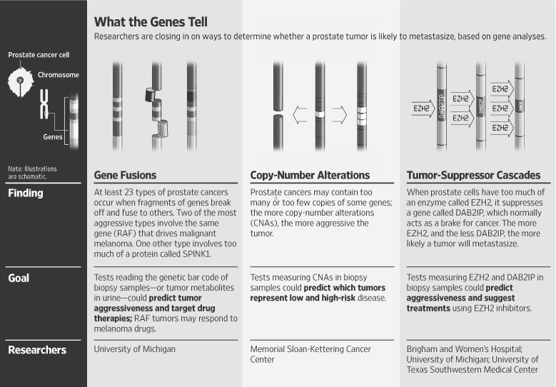

Most of the remaining prostate-cancer types involve fusions of a gene called ETS, and they are more or less virulent depending on which fragments of other genes are fused to them. Jonathan Simons, chief executive officer of the Prostate Cancer Foundation, which funds much of the Michigan research, likens the process to rebuilding car engines out of random automotive parts.
"If you have a tumor with a lawn-mower engine, it may look like a cancer, we may call it a cancer, but it may never be a problem in the life of a 72-year old man," he says. "But if you have a cancer with a bulky Dodge Hemi stuck to a BMW 850csi V-12 engine, that needs treatment."
Four of the 24 cancer types discovered, which together make up over 50% of the prostate cancers classified so far, have the equivalent of lawn-mower engines and probably don't have enough power to grow past the prostate gland, Dr. Simons says. Another 20% are more highly powered and could pose problems in the presence of other gene fusions.
Getting Aggressive
And one of the most aggressive types, representing 10% to 15% of prostate cancers, appears to follow a different mechanism: It results when there are excess amounts of a protein known as SPINK1. Since the protein shows up in urine, the researchers say a urine test could be designed to measure its presence.
There could be more types, represented by different genetic bar codes. "We are finding more every month or so, filling in the gaps," says the lead investigator Arul Chinnaiyan, director of the Michigan Center for Translational Pathology. To validate the findings, researchers, who so far have studied some 300 tumor samples, plan to analyze at least 1,000 samples and to follow how the patients progress.
"We are not there yet, but within the next year, we hope to have a clinical lab test where we can predict what kind of cancer a man has," says Dr. Chinnaiyan.
Researchers at Memorial Sloan-Kettering are studying a different kind of genetic error involved in prostate cancer. Instead of two copies of a gene, some cancer cells have too many or too few, known as copy-number alterations.
In a study in the journal Cancer Cell last week, the researchers analyzed the copy-number alterations in 218 cancerous prostates surgically removed at Sloan-Kettering and found that they fell into six clusters. Those clusters corresponded closely with how quickly the patients' cancer returned, judging by their PSA.
"It was a surprise to us that so much prognostic information was there in the original samples after surgery," Dr. Sawyers says. Ideally, "we'd be able to tell a man, 'Your tumor looks like it's in cluster five, so you should get surgery and radiation and perhaps even more aggressive therapy. Or, you are in cluster two, so you can relax and maybe just get another biopsy in another year and see if your cluster has changed," he says.
Tracking Patients
Further testing at Sloan Kettering is continuing. The researchers have 1,000 additional samples from prostates removed more than 10 years ago and can correlate their findings with how the patients fared in that time.
In still another recent breakthrough, researchers at Harvard Medical School identified a gene pathway directly involved in prostate-cancer metastasis. They isolated a gene, DAB2IP, that acts as a brake for cancer. When too much of an enzyme, EZH2, is present, the DAB2IP gene is suppressed, removing the brake and allowing the cancer to spread.
"It's more than just correlation; it's cause and effect," says lead researcher Karen Cichowski, a cancer biologist, who demonstrated the process in mice in a study in Nature Medicine this year. The Harvard researchers also studied data from human prostate cancers and found that the patients with the most aggressive tumors had either excess EZH2 or too little DAB2IP or both.
These findings, too, could yield tests to predict how aggressive a patient's prostate cancer could be. Several biotech companies have drugs in the works to inhibit EZH2.
The various research findings complement each other by describing different ways that genes mutate as cancers evolve, says Dr. Chinnaiyan. He expects that diagnostic tests in the future will look at a variety of genes, as well as proteins, molecules and other "biomarkers" to predict how aggressive a cancer might be.
Previously
The Man, the Gland, the Dilemmas (3/31/2009)
Prostate Cancer: Weighing Options (4/7/2009)
Health Matters: Weighing the Benefits of 'Watchful Waiting' for Prostate Cancer (4/17/2009)
Another technique being applied to prostate cancer involves magnetic resonance spectroscopy, a form of imaging that tracks chemical changes in tissues. In a small study in the journal Science Translational Medicine this year, researchers at Harvard showed that the scanning technology can not only locate cancers within the prostate, but also has the potential to distinguish fast and slow-moving cancers.
Progress is also being made on ways to measure prostate cancers through simple blood and urine tests, or what scientists call "liquid biopsies." The biotech firm Gen-Probe Inc., working with the University of Michigan researchers, has developed a test for a gene called PCA3 that shows up in urine only when a man has prostate cancer.
For now, the PCA3 test is mainly useful to tell men who have a rising PSA level that they should have a biopsy as well, or for men who have a negative biopsy that might have missed cancer. Dr. Chinnaiyan hopes the PCA3 test can also check for gene fusions that can identify which type of prostate cancer a man has.
'Liquid Biopsies'
The PCA3 test is not yet approved by the Food and Drug Administration, but it is approved for use in Europe and is available in several U.S. labs on an investigational basis.
In other prostate-cancer news, there's more evidence that cholesterol-lowering statin drugs may play a role in controlling the spread of prostate cancer. In a study in the journal Cancer, researchers at Duke University Medical Center and elsewhere analyzed the records of 1,319 men who had their prostates removed between 1988 and 2008 and found that 304 of them had a rising PSA level after surgery, which generally indicates that the cancer has reoccurred and spread. Men who were taking the equivalent of 20 mg of simvastatin a day were 43% less likely to see a recurrence. In men taking a higher dose, the risk of recurrence was reduced by 50%.
The researchers cautioned that the reduced risk could be due to factors other than statins, such as diet, exercise or smoking habits; only a randomized clinical trial could tell for sure. Five other recent studies also have found that statins appear to lower the risk for advanced prostate cancer.
Write to Melinda Beck at HealthJournal@wsj.com

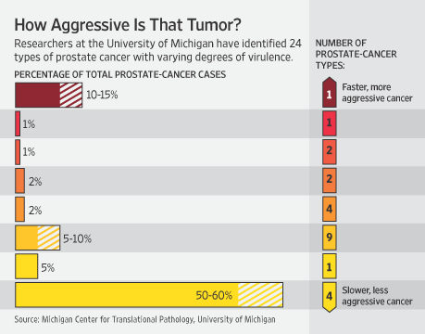

Copyright 2011 Dow Jones & Company, Inc. All Rights Reserved
This copy is for your personal, non-commercial use only. Distribution and use of this material are governed by our Subscriber Agreement and by copyright law. For non-personal use or to order multiple copies, please contact Dow Jones Reprints at 1-800-843-0008 or visit
www.djreprints.com

