Neil E. Fleshner

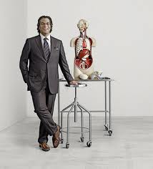

Dr. Fleshner is a Professor in the Department of Surgery at the University of Toronto and is currently Head of the Division of Urology at the University Health Network and Princess Margaret Hospital. His clinical practice focuses on the prevention and surgical treatment of urologic malignancy, with an emphasis on prostate cancer. His current research priorities include translational, clinical and health services including but not limited to the understanding of prostate cancer pathogenesis, progression and prevention. He has taken part in many randomized trials looking at nutritional intervention in prostate cancer. He oversees a basic research laboratory focusing on the assessment of oxidative biomarkers and cell cycle regulation in prostate cancer cells exposed to micronutrients. His research is or has been funded by the National Cancer Institute of Canada, Medical Research Council of Canada, Canadian Prostate Cancer Research Foundation, Canadian Institute of Health Research and National Institute of Health. He has authored more than 215 publications and has served on the faculty of numerous postgraduate courses and has been an invited lecturer around the world. He has most recently been awarded the inaugural Love Chair in Prostate Cancer Prevention.

