[[](https://aspatients.org/)Active Surveillance Patients International](https://aspatients.org/)

**Active Surveillance Patients International**

**The Leading Edge of Active Surveillance for Prostate Patients and Urologists**

**Saturday July 31 @ 12:00 pm - 1:30 pm EDT**

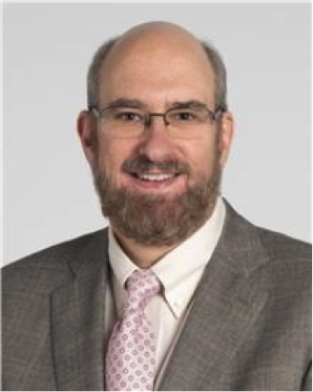

**Renowned Cleveland Clinic Urologist Dr. Eric Klein Discusses Active Surveillance.**

***Dr. Klein answers the questions: “What do I actually do while I’m on Active Surveillance?”  
What tests should I be taking and how often?  
How do I know if I qualify for Active Surveillance?  
What indicators will tell me that I must go off Active Surveillance and seek active treatment?***

***Eric A. Klein, MD, is the Chairman of the Glickman Urological & Kidney Institute and a staff member in the Taussig Cancer Institute at Cleveland Clinic. His clinical interests are cancers of the prostate,  testis and kidney.  For several years, including the current edition, Dr. Klein is listed in Best Doctors in America.***

***Board-certified in urology, Dr. Klein is a frequent lecturer and visiting professor at numerous national and international universities. He was the National Medical Study Coordinator for the National Cancer Institute sponsored Selenium and Vitamin E Cancer Prevention Trial (SELECT). Dr. Klein is the editor of Urology and has been the recipient of numerous awards from the American Cancer Society, the University of Pittsburgh School of Medicine, and the Cleveland Clinic.***

***Dr. Klein received his medical degree from University of Pittsburgh School of Medicine in Pennsylvania. He completed his residency in urology at Cleveland Clinic and a fellowship in urology at the Memorial Sloan Kettering Cancer Center in New York.***

**Be sure to send in your questions.**

*[To Register Click Here](https://us02web.zoom.us/meeting/register/tZUvceGuqjsoE9K8_1Pswqv4k0XIA4VLzeEC)*