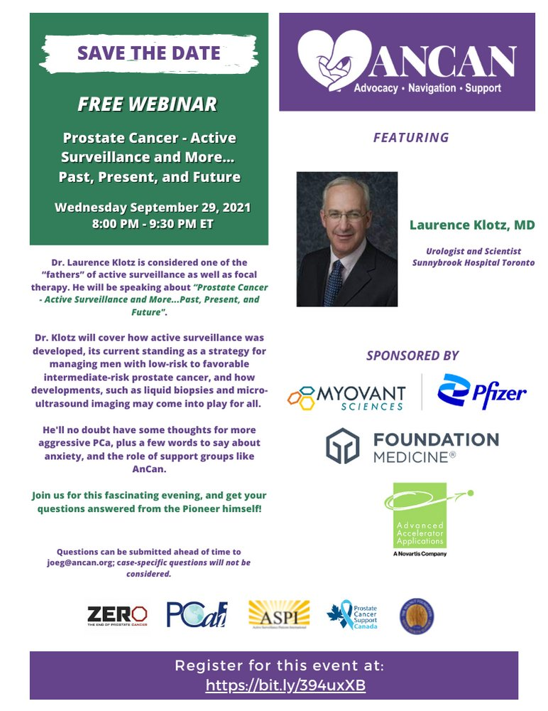

<https://bit.ly/394uxXB>